Metasploitable 2 — Information Gathering & Reconnaissance Report
1. Objective
The objective of this lab was to perform information gathering and reconnaissance against an intentionally vulnerable Metasploitable 2 virtual machine using Kali Linux.
The lab focused on identifying the target, discovering open ports and services, detecting service versions, identifying the operating system, and gathering web-related information.

2. Lab Environment
Component | Details
Attacker Machine | Kali Linux
Target Machine | Metasploitable 2
Kali IP | 192.168.200.130
Target IP | 192.168.200.131
Network | 192.168.200.0/24
Purpose | Authorized cybersecurity practice lab

3. Tools Used
The following tools were used during the reconnaissance process:
- Ping
- Nmap
- dig
- nslookup
- WhatWeb
- WHOIS
- Subdomain enumeration tools

4. Target Connectivity
Objective
The first step was to verify that the Kali Linux machine could communicate with the Metasploitable 2 target.
Command Used
ping -c 4 192.168.200.131
Observation
The target responded to the ICMP requests, confirming connectivity between the Kali Linux machine and the Metasploitable 2 virtual machine.
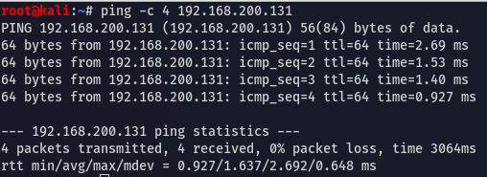
Screenshot

5. Host Discovery
Objective
Host discovery was performed to identify active systems within the lab network.
Command Used
nmap -sn 192.168.200.0/24
Observation
The scan identified active hosts on the local lab network, including the Metasploitable 2 target.
Screenshot
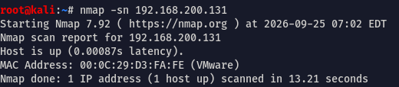

6. Port Scanning
Objective
Nmap was used to identify open TCP ports on the Metasploitable 2 target.
Command Used
nmap 192.168.200.131
Observation
The scan identified multiple open ports on the target. These ports indicated the presence of several network service

7. Service and Version Enumeration
Objective
Service and version detection was performed to identify the applications and versions running on the discovered ports.
Command Used
nmap -sV 192.168.200.131
Observation
Nmap identified several services and their corresponding versions. Version information can be useful during vulnerability assessment because specific software versions may have known security vulnerabilities.
Key findings
Port service version
21/tcp ftp vsftpd 2.3.4
Screenshot
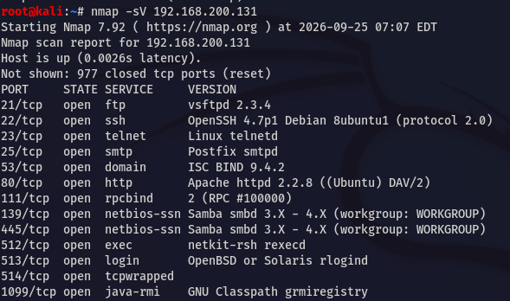

8. Operating System Detection
Objective
Nmap OS detection was used to identify the probable operating system of the target.
Command Used
sudo nmap -O 192.168.200.131
Observation
Nmap identified the probable operating system and kernel information of the Metasploitable 2 target.
Screenshot
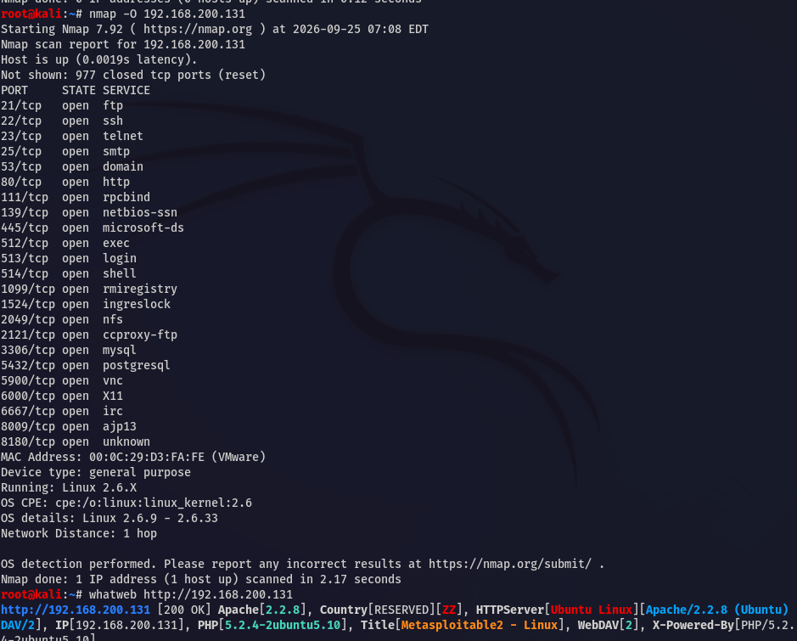

9. DNS Enumeration
Objective
DNS enumeration was practiced to understand how DNS records can provide information about domains and their infrastructure.
Commands Used
dig <authorized-domain> A
dig <authorized-domain> MX
dig <authorized-domain> NS
dig <authorized-domain> TXT
dig <authorized-domain> SOA
nslookup <authorized-domain>
Observation
Different DNS record types were queried and their responses were analyzed.
Important Record Types
Record | Purpose
A | Maps a domain to an IPv4 address
AAAA | Maps a domain to an IPv6 address
MX | Identifies mail servers
NS | Identifies authoritative name servers
TXT | Contains text-based information
SOA | Provides administrative information about a DNS zone

10. Web Technology Enumeration
Objective
WhatWeb was used to identify technologies associated with the web server running on the target.
Command Used
whatweb http://192.168.200.131
Observation
The scan provided information about the web server, operating system, and web technologies detected on the target.
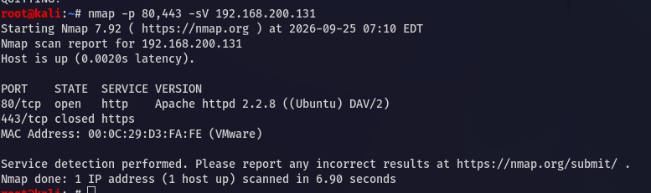
Screenshot

11. Key Observations
The reconnaissance process revealed:
- The target was reachable from the Kali Linux machine.
- Multiple network ports were open on the target.
- Several services and their versions could be identified.
- Operating system information could be estimated using Nmap.
- Web technologies running on the target could be identified.
- DNS enumeration demonstrated how DNS records can reveal infrastructure-related information.

12. Security Relevance
Reconnaissance is an important phase of penetration testing because information collected during this phase can help identify the attack surface of a target.
Information such as:
- IP addresses
- Open ports
- Running services
- Software versions
- Operating systems
- DNS records
- Web technologies
can be used during subsequent vulnerability assessment and security testing.

13. Lessons Learned
Through this lab, I gained practical experience with reconnaissance and information gathering tools and learned how to correlate information from different sources instead of relying on a single tool.
I also learned the difference between:
- Host discovery
- Port scanning
- Service enumeration
- OS detection
- DNS enumeration
- Web technology enumeration

14. Conclusion
This lab provided hands-on experience with the information gathering and reconnaissance phase of security testing.
The next stage of the lab will focus on analyzing the discovered services and identifying potential vulnerabilities within the authorized Metasploitable 2 environment.

Disclaimer
This project was performed in an isolated, authorized cybersecurity laboratory using Metasploitable 2, an intentionally vulnerable virtual machine.
The techniques demonstrated in this project should only be used against systems for which proper authorization has been obtained.

